**Empty an S3 Bucket**

* Selecting the S3 bucket you want to empty

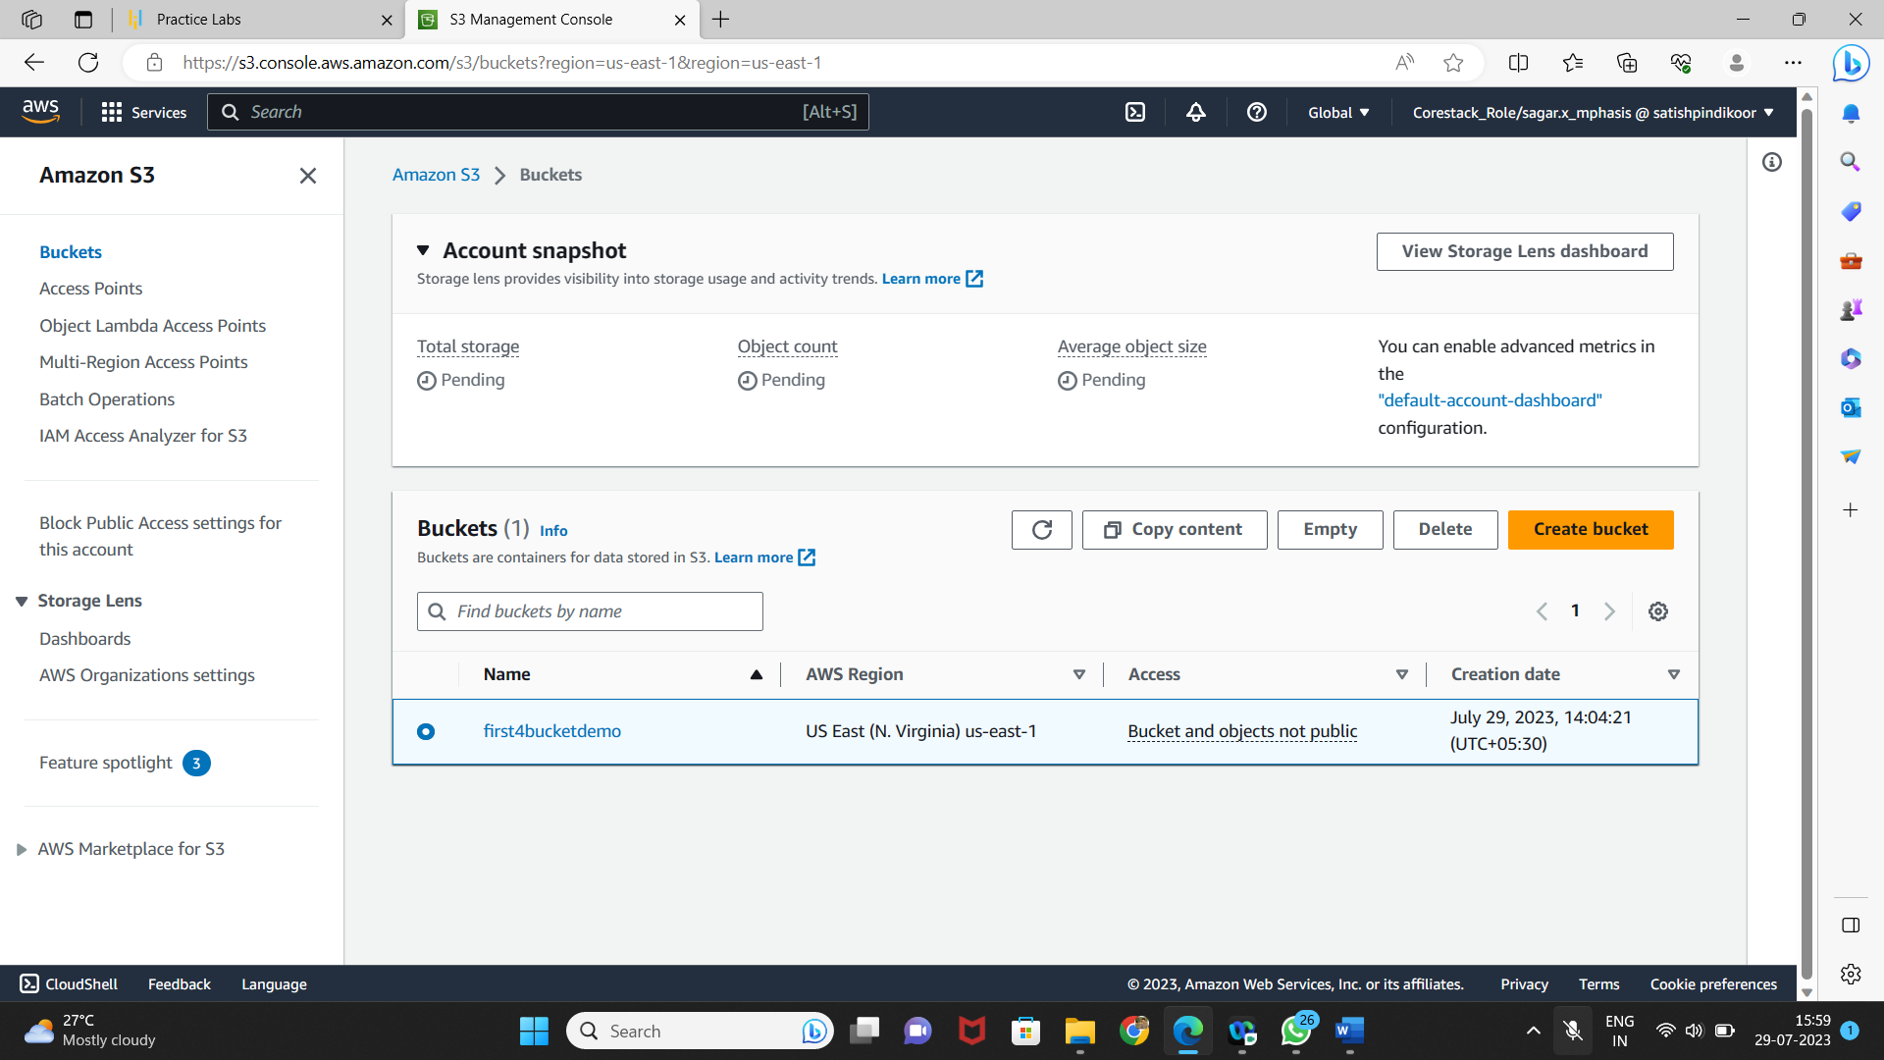

* Emptying the bucket
* Verify the content present in the bucket

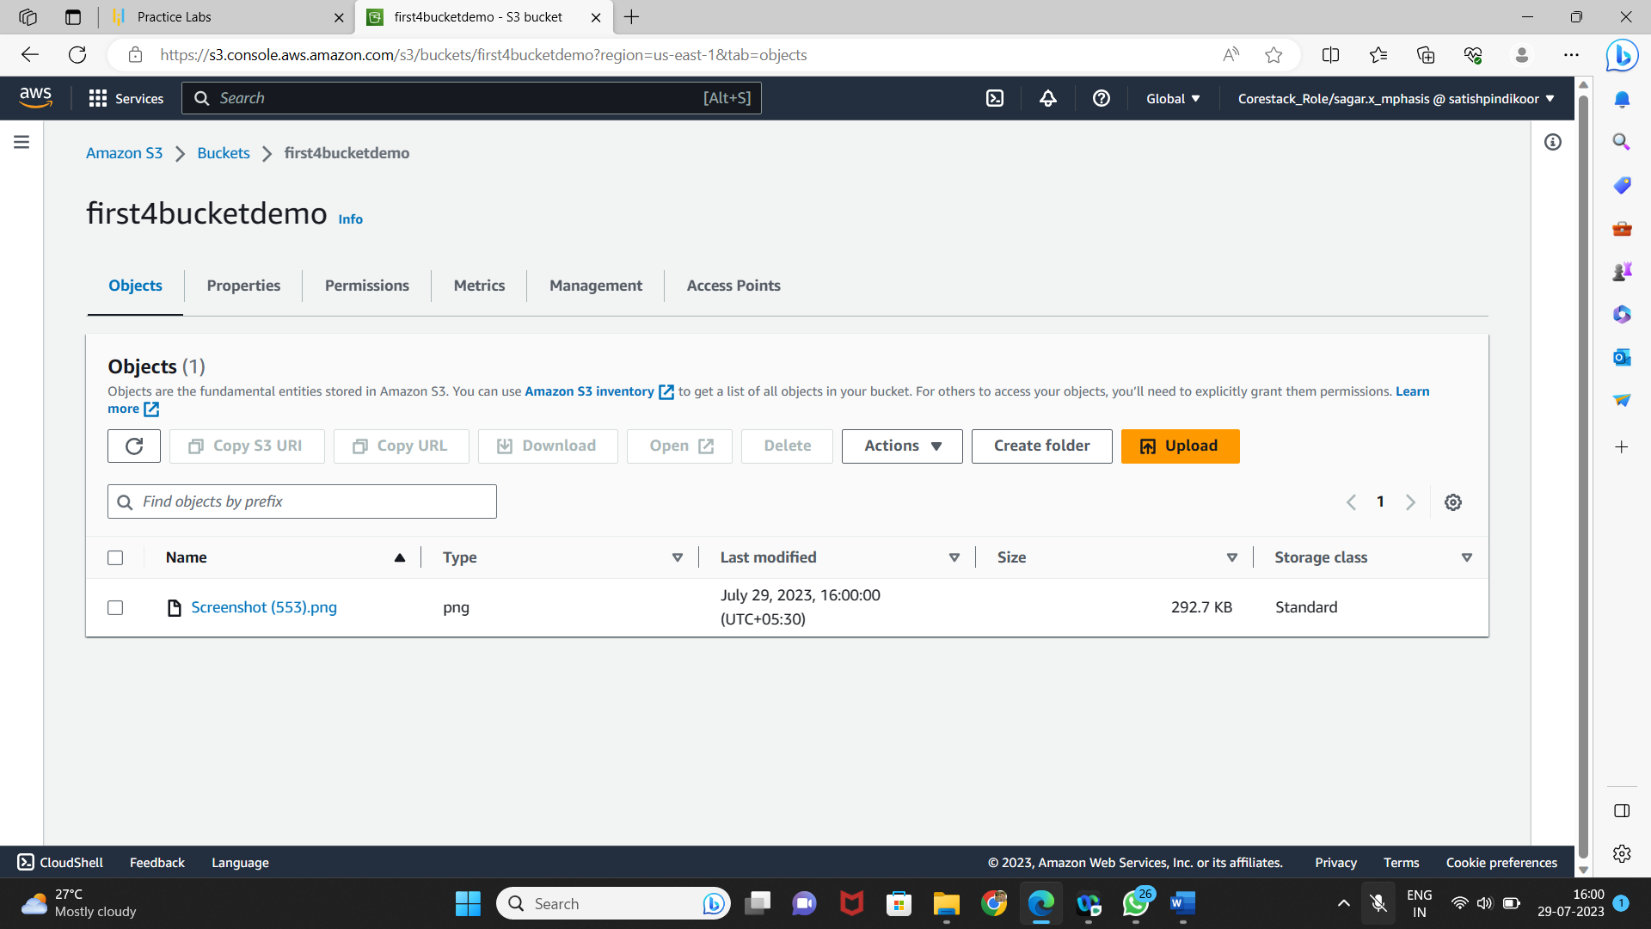

* Empty the bucket

